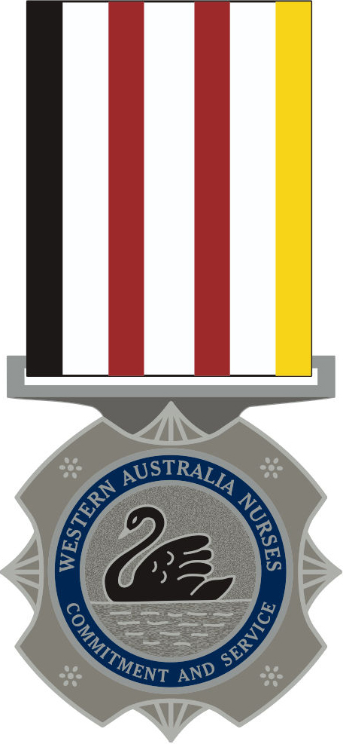 | WESTERN AUSTRALIA NURSING SERVICE MEDAL  APPLICATION FORM

Surname: |  | First Name: | Middle Name:
Date Of Birth: | Registration No : Nursing Category:
CONTACT DETAILS:

Address:
Phone No: |  | Email:
WORK HISTORY
Where possible, please attach any supporting documentation such as Certificate of Service that may assist in verifying commencement and cessation dates.

NURSING TRAINING:
Hospital Based Date training commenced:
University/TAFE Date training ceased:
Name of training organisation:
Date Registered within Western Australia:
Current employment status (please tick):
Current Medical Retirement
Resignation Posthumous Application
Retirement Other
Current employer:

POST REGISTRATION EXPERIENCE
(Please ensure that we at least have the month as well of the year)
HOSPITAL | CAPACITY IN WHICH EMPLOYED | FROM  Both month & Year |  |  | TO  Both month & Year |  |  | EXPERIENCE IN YEARS
Sample Hospital | EN |  | MM | YYYY |  | MM | YYYY

POST REGISTRATION EXPERIENCE (Continued)
HOSPITAL | CAPACITY IN WHICH EMPLOYED | FROM |  |  | TO |  |  |  | EXPERIENCE IN YEARS
TOTAL YEARS OF NURSING SERVICE

Signature: | Date: / / _

Honours and Awards Use Only
Acknowledgement sent: ____________________ | Entered on Schedule: ____________________
Confirm Start date: ____________________ | Confirm Cessation date: ____________________
Student Service: Yes No | Confirm Student Service: ____________________
Ethical & Diligent Service: Yes No | Integrity Check: Yes No
Eligible: Yes No
Presentation Advice Sent: ____________________ | Date Fwd ______/______/______
Medal  15 yr  20 yr  25 yr  30 yr  35 yr  40 yr  45 yr 
Other ________________________________________________________________________________________________________

Forward the completed application form for consideration to:
Medals for Nurses
PO Box 1157
Kelmscott DC WA 6997

